**CPP NOTES – DAY 07**

FYI- to exclude any files in src dir from build, right click on the file -> properties -> Exclude from build -> Yes

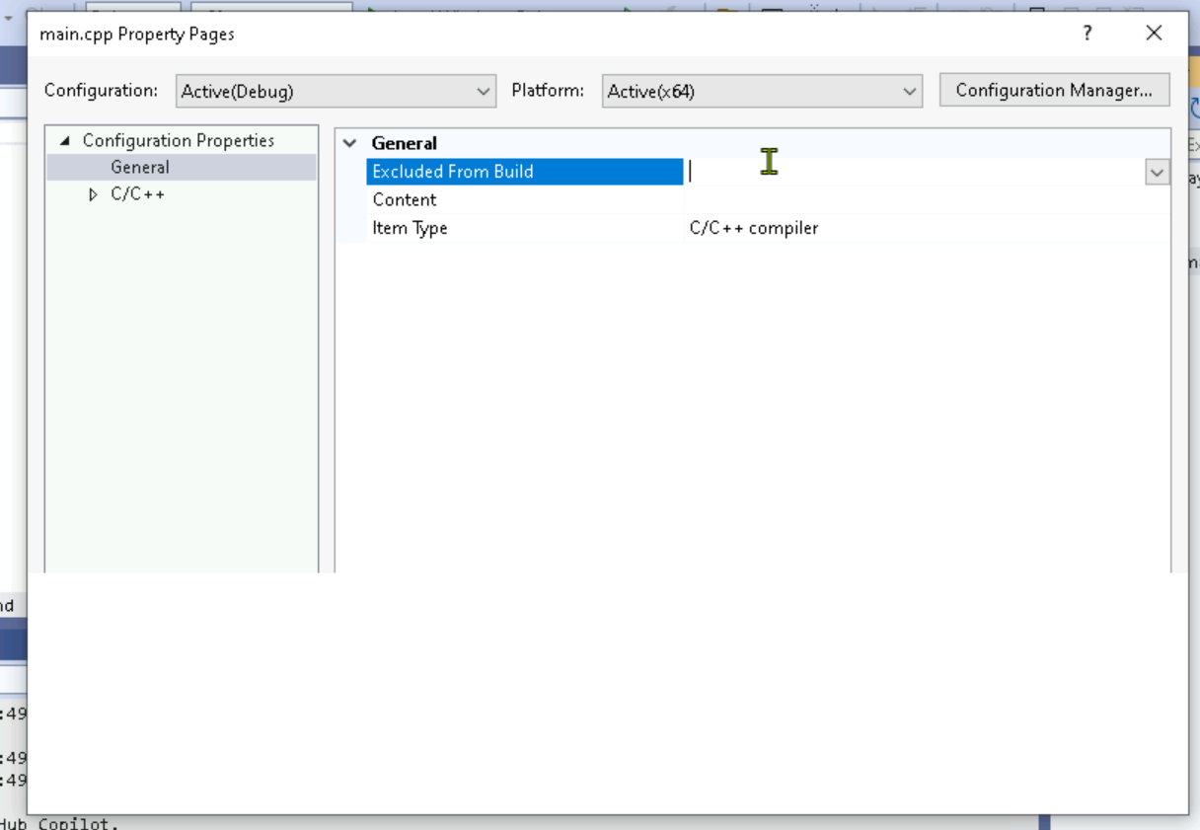

**Do…while Loop**

type of loop in C that executes a block of code until the given condition is satisfied. The feature of do while loops is that unlike the while loop, which checks the condition before executing the loop, the do…while loop ensures that the code inside the loop is executed at least once, even if the condition is false from the start.

***do*** *{ 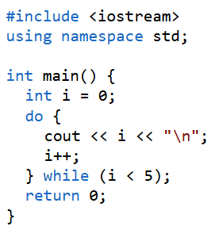 // Body of the loop  
// Update expression  
}* ***while (condition)****;*

*Q: Why does do while have ; at end of while condition?*